THE THIRD SUNDAY OF LENT -- March 15, 2020
GATHERING OURSELVES TOGETHER

Welcome
Prelude

*Opening Hymn “Come, Thou Fount of Every Blessing” #45

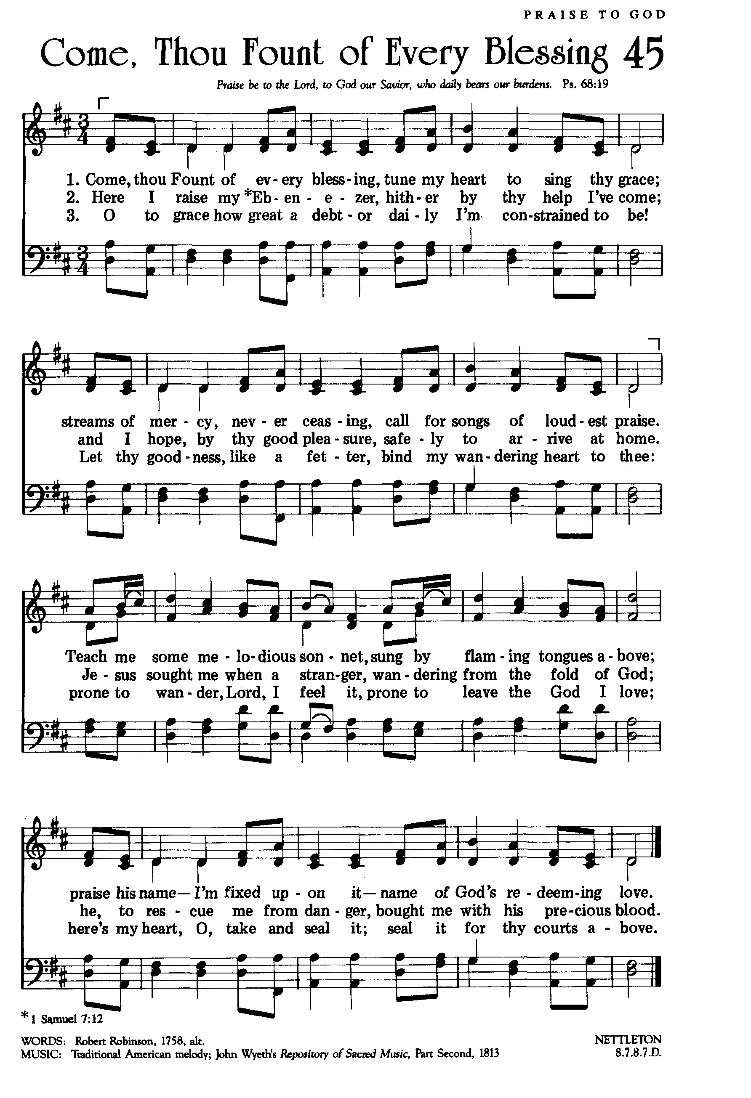

PRESENTING OURSELVES TO GOD
*Call To Worship (Psalm 95)
Leader: O come, let us sing to the Lord;
People: let us make a joyful noise to the rock of our salvation!
Leader: Let us come into his presence with thanksgiving;
People: let us make a joyful noise to him with songs of praise!
Leader: The sea is his, for he made it,
People: and the dry land, which his hands have formed.
Unison: O come, let us worship and bow down,
let us kneel before the Lord, our Maker!
For he is our God,
and we are the people of his pasture,
and the sheep of his hand.

*Prayer for Forgiveness & Reconciliation
O God, our leader and our guide, you bring us to new birth to live as your children. We question, we doubt, we struggle, we resist, and yet we sit with you. We seek and we listen and we hope and we trust, because you have strengthened us in faith, with water, Word, bread and wine. Forgive our lack of trust. Forgive us our inability to step out in faith. Strengthen us in the Spirit so we may lift up your life-giving love to all the world through your Son, Jesus Christ, our Savior and Lord. Amen.

Announcements

Sharing our Joys and Concerns
Call to Prayer & Response
Pastoral Prayer and Silent Prayer
Our Lord’s Prayer

GOD’S WORD TO US

Old Testament Reading: Exodus 17:1-7
New Testament Reading: John 4:5-15

Sermon: “Living Water,” Ed Gabrielsen, seminary intern.

Remembering Our Baptism

ENTERING THE WORLD

*Closing Hymn “Guide Me, O Thou Great Jehovah” #634 (see below)

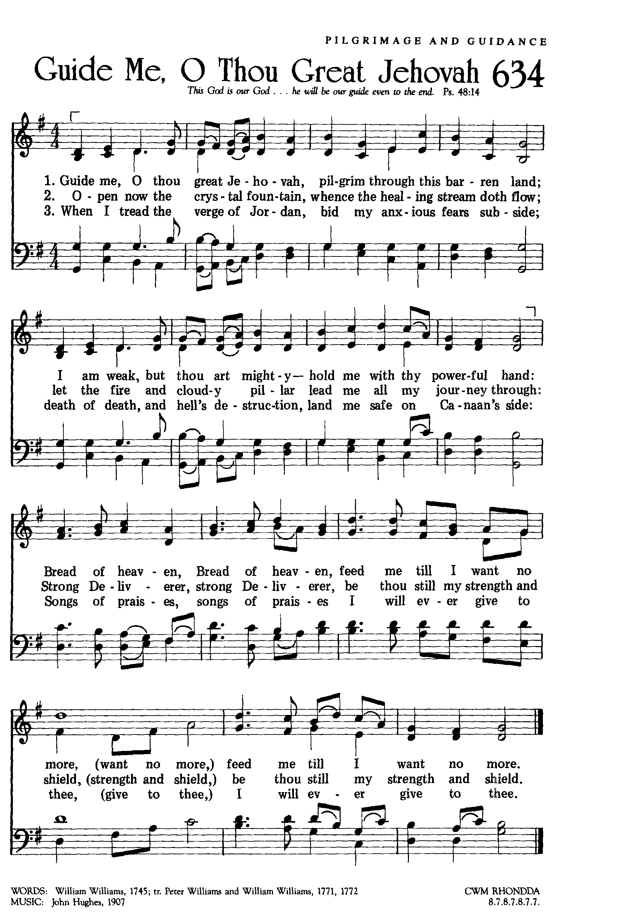

*Benediction

